**Week 4 Homework Submission File: Linux Systems Administration**

**Step 1: Ensure/Double Check Permissions on Sensitive Files**

1. Permissions on /etc/shadow should allow only root read and write access.
   * Command to inspect permissions:
   * Command to set permissions (if needed):
2. Permissions on /etc/gshadow should allow only root read and write access.
   * Command to inspect permissions:
   * Command to set permissions (if needed):
3. Permissions on /etc/group should allow root read and write access, and allow everyone else read access only.
   * Command to inspect permissions:
   * Command to set permissions (if needed):
4. Permissions on /etc/passwd should allow root read and write access, and allow everyone else read access only.
   * Command to inspect permissions:
   * Command to set permissions (if needed):

**COMMANDS;**

*sysadmin@UbuntuDesktop:/etc$ sudo chmod 600 shadow*

*sysadmin@UbuntuDesktop:/etc$ ls -l shadow*

*-rw------- 1 root shadow 2888 May 14 16:31 shadow*

*sysadmin@UbuntuDesktop:/etc$ ls -l gshadow*

*-rw-r----- 1 root shadow 1076 May 14 16:31 gshadow*

*sysadmin@UbuntuDesktop:/etc$ sudo chmod 600 gshadow*

*sysadmin@UbuntuDesktop:/etc$ ls -l gshadow*

*-rw------- 1 root shadow 1076 May 14 16:31 gshadow*

*sysadmin@UbuntuDesktop:/etc$ ls -l group*

*-rw-r--r-- 1 root root 1303 May 14 16:31 group*

*sysadmin@UbuntuDesktop:/etc$ ls -l passwd*

*-rw-r--r-- 1 root root 3214 May 14 16:31 passwd*

*sysadmin@UbuntuDesktop:/etc$*

**Step 2: Create User Accounts**

1. Add user accounts for sam, joe, amy, sara, and admin.
   * Command to add each user account (include all five users):

*Commands:*

*sudo adduser sam*

*sudo adduser joe*

*sudo adduser amy*

*sudo adduser sara*

*sudo adduser admin*

*(temp password for all == big[name])*

1. Force users to create 16-character passwords incorporating numbers and symbols.
   * Command to edit pwquality.conf file:
   * Updates to configuration file:

*Commands:*

*/etc/security/pwquality.conf*

*minlen = 16*

*dcredit = 1*

*ucredit = 1*

*lcredit = 1*

*ocredit = 1*

*minclass = 4*

*(edited and then save as sudo w/sysadmin credentials)*

*chage -d 0 sam*

*chage -d 0 joe*

*chage -d 0 amy*

*chage -d 0 sara*

*chage -d 0 admin*

*(to trigger a password reset at first login)*

1. Force passwords to expire every 90 days.
   * Command to to set each new user's password to expire in 90 days (include all five users):

*Commands:*

*sudo chage –M 90 {user} (sets password change in 90 days)*

*sudo chage –l {user} (lists out user password account info)*

*date –d “+120 days” +%F (gets the date 120 days from now)*

*Other Commands Found:*

*To reset the policy for all user you could user the /etc/login.defs file and edit:*

*PASS_MAC_DAYS 90*

*PASS_MIN_DAYS 1*

*PASS_WARN_AGE 7*

1. Ensure that only the admin has general sudo access.
   * Command to add admin to the sudo group:

*Commands:*

*sudo usermod –aG sudo admin*

*Results:*

*sysadmin@UbuntuDesktop:/etc$ sudo usermod -aG sudo admin*

*[sudo] password for sysadmin:*

*sysadmin@UbuntuDesktop:/etc$ groups admin*

*admin : admin sudo*

**Step 3: Create User Group and Collaborative Folder**

1. Add an engineers group to the system.
   * Command to add group: ***sudo groupadd engineers***
2. Add users sam, joe, amy, and sara to the managed group.
   * Command to add users to engineers group (include all four users):

***sudo usermod –aG engineers sam***

***sudo usermod –aG engineers joe***

***sudo usermod –aG engineers amy***

***sudo usermod –aG engineers sara***

***sudo usermod –aG engineers admin***

1. Create a shared folder for this group at /home/engineers.
   * Command to create the shared folder: ***sudo mkdir –p /home/engineers***
2. Change ownership on the new engineers' shared folder to the engineers group.
   * Command to change ownership of engineer's shared folder to engineer group:

***sudo chgrp –R engineers /home/engineers***

***sudo chmod –R 2775 /home/engineers***

*Other Commands Found:*

*S sudo useradd –m –c “user name” –s/bin/bash -G {user}*

*S sudo mkdir -p /home/engineers/{user}*

**Step 4: Lynis Auditing**

1. Command to install Lynis:

*(Followed instructions from Cisofy:* [*CISOfy Software Repository (Community)*](https://packages.cisofy.com/community/#debian-ubuntu)*)*

*Commands:*

*sudo apt-key adv --keyserver keyserver.ubuntu.com --recv-keys 013baa07180c50a7101097ef9de922f1c2fde6c4*

*sudo apt install apt-transport-https*

*echo 'Acquire::Languages "none";' | sudo tee /etc/apt/apt.conf.d/99disable-translations*

*echo "deb https://packages.cisofy.com/community/lynis/deb/ stable main" | sudo tee /etc/apt/sources.list.d/cisofy-lynis.list*

*sudo apt update*

*sudo apt linstall lynis*

1. Command to see documentation and instructions: [*Lynis Installation and Usage Guide - CISOfy*](https://cisofy.com/documentation/lynis/)*, man lynis, lynis show*
2. Command to run an audit: ***lynis audit system***
3. Provide a report from the Lynis output on what can be done to harden the system.
   * Screenshot of report output:

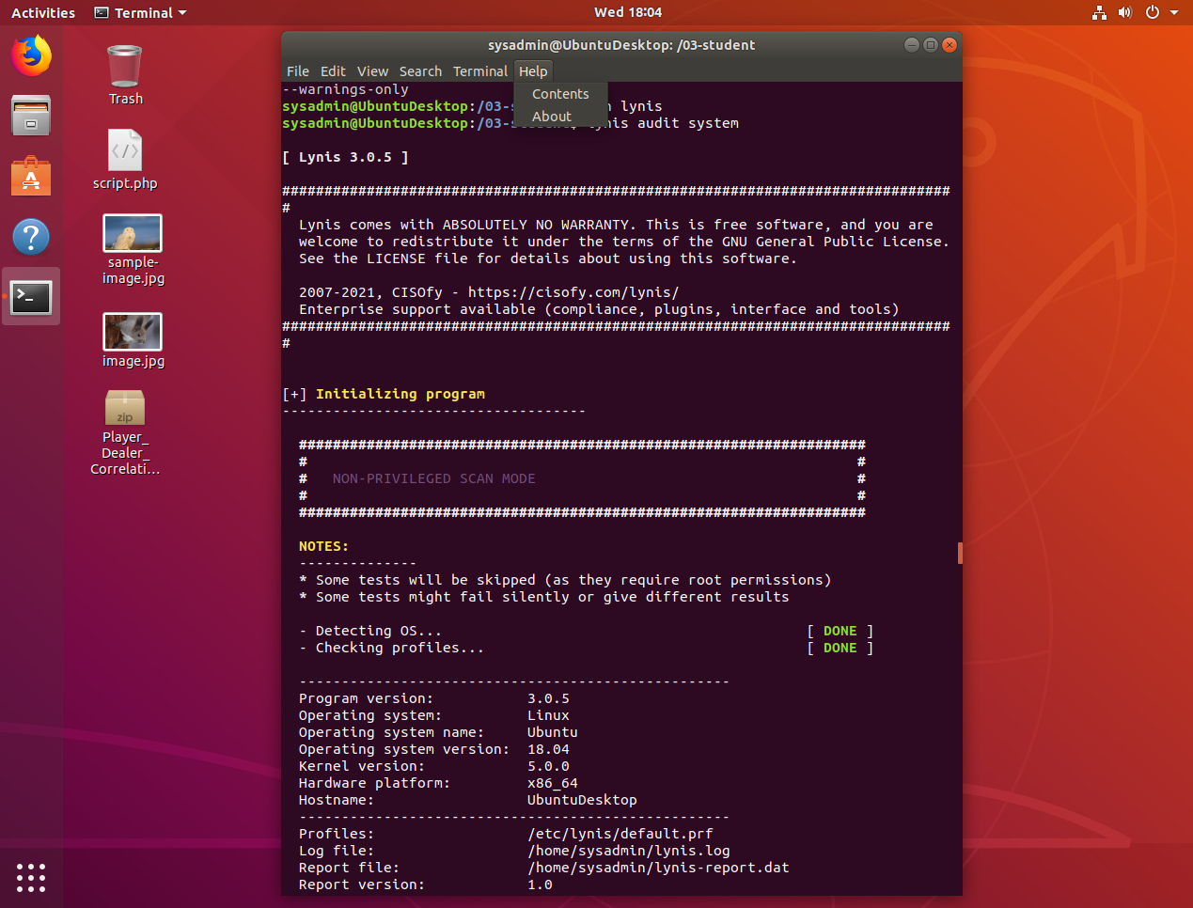

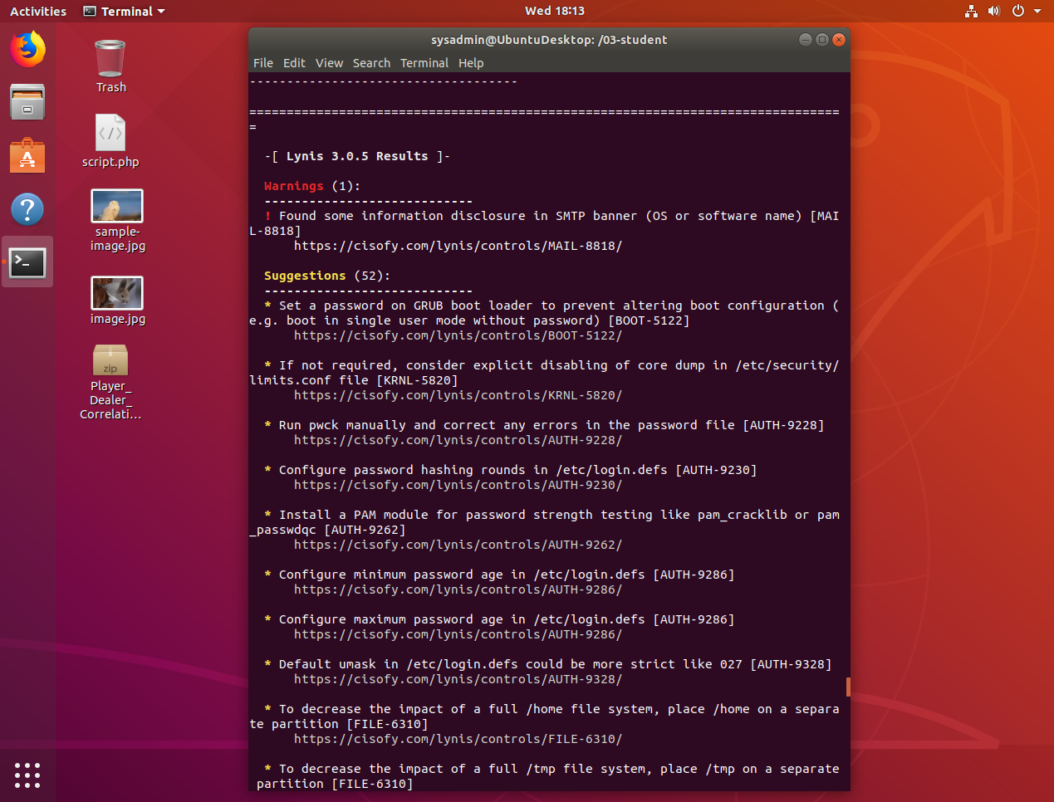

**Etc…**

**Bonus**

1. Command to install chkrootkit:

***sudo apt-get update***

***sudo apt install chkrootkit***

***sudo chkrootkit –V (showed version - chkrootkit version 0.52)***

1. Command to see documentation and instructions:

***sudo chkrootkit –h , sudo chkrootkit –l ,*** [*How to Install CHKROOTKIT on Ubuntu 18.04/Centos 7 (linoxide.com)*](https://linoxide.com/install-chkrootkit-linux/)

1. Command to run expert mode: ***sudo chkrootkit –x,***
2. Provide a report from the chrootkit output on what can be done to harden the system.
   * Screenshot of end of sample output:

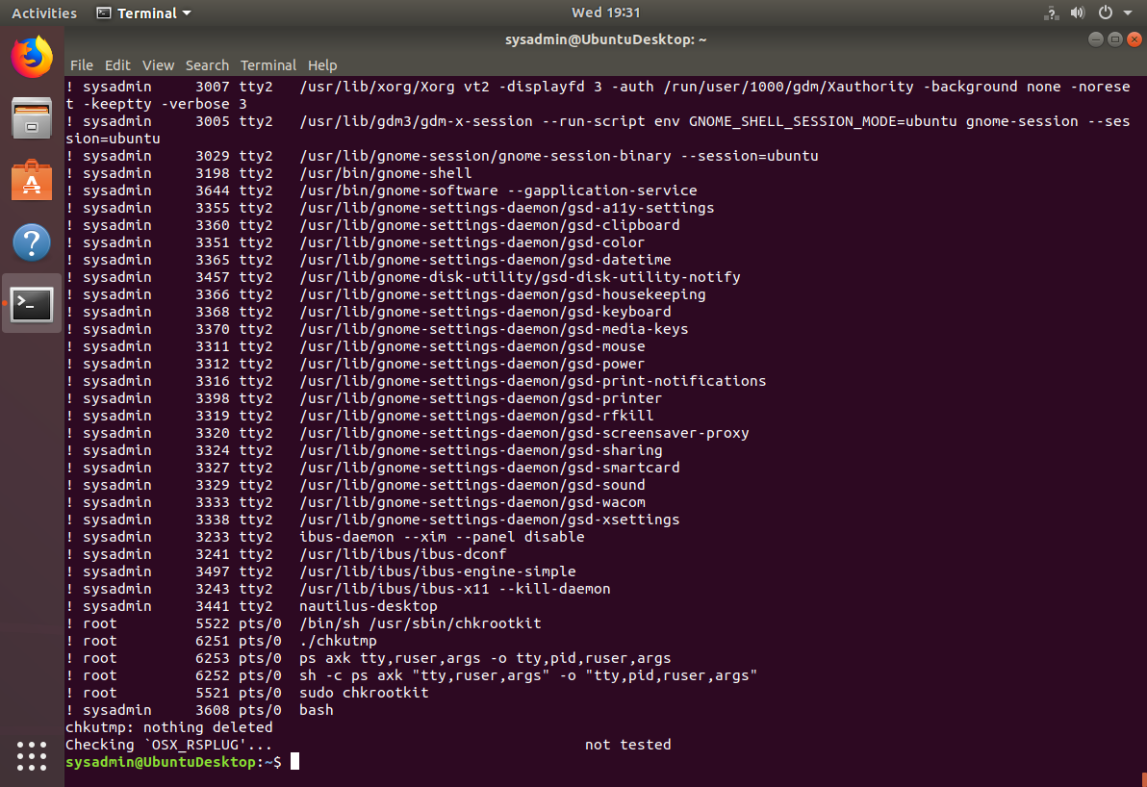

© 2020 Trilogy Education Services, a 2U, Inc. brand. All Rights Reserved.

COMMANDS/OUTPUT

sysadmin@UbuntuDesktop:/etc$ su admin

No passwd entry for user 'admin'

sysadmin@UbuntuDesktop:/etc$ sudo adduser admin

Adding user `admin' ...

Adding new group `admin' (1018) ...

Adding new user `admin' (1016) with group `admin' ...

Creating home directory `/home/admin' ...

Copying files from `/etc/skel' ...

Enter new UNIX password:

Retype new UNIX password:

passwd: password updated successfully

Changing the user information for admin

Enter the new value, or press ENTER for the default

Full Name []:

Room Number []:

Work Phone []:

Home Phone []:

Other []:

Is the information correct? [Y/n]

sysadmin@UbuntuDesktop:/etc$

sysadmin@UbuntuDesktop:/etc$

sysadmin@UbuntuDesktop:/etc$ sudo chage -M 90 sam

[sudo] password for sysadmin:

sysadmin@UbuntuDesktop:/etc$ sudp chage -l sam

Command 'sudp' not found, did you mean:

command 'ssdp' from snap ssdp (0.0.1)

command 'sudo' from deb sudo

command 'sudo' from deb sudo-ldap

command 'sfdp' from deb graphviz

command 'sup' from deb sup

See 'snap info <snapname>' for additional versions.

sysadmin@UbuntuDesktop:/etc$ sudo chage -l sam

Last password change : Jul 14, 2021

Password expires : Oct 12, 2021

Password inactive : never

Account expires : never

Minimum number of days between password change : 0

Maximum number of days between password change : 90

Number of days of warning before password expires : 7

sysadmin@UbuntuDesktop:/etc$ date -d "+120 day" +%F

2021-11-11

sysadmin@UbuntuDesktop:/etc$ sudo chage -M 90 joe

sysadmin@UbuntuDesktop:/etc$ sudo chage -M 90 amy

sysadmin@UbuntuDesktop:/etc$ sudo chage -M 90 sara

sysadmin@UbuntuDesktop:/etc$ sudo chage -M 90 admin

sysadmin@UbuntuDesktop:/etc$ groups admin

admin : admin

sysadmin@UbuntuDesktop:/etc$ groups joe

joe : joe

sysadmin@UbuntuDesktop:/etc$ groups amy

amy : amy

sysadmin@UbuntuDesktop:/etc$ groups sara

sara : sara

sysadmin@UbuntuDesktop:/etc$ groups admin

admin : admin

sysadmin@UbuntuDesktop:/etc$ sudo usermod -aG sudo admin

[sudo] password for sysadmin:

sysadmin@UbuntuDesktop:/etc$ groups admin

admin : admin sudo

sysadmin@UbuntuDesktop:/etc$ ls /home

adam amy http jack joe max sam student user.hashes

admin billy instructor jane john sally sara sysadmin vagrant

sysadmin@UbuntuDesktop:/etc$ sudo groupadd engineers

[sudo] password for sysadmin:

sysadmin@UbuntuDesktop:/etc$ groups

sysadmin adm cdrom sudo dip plugdev lpadmin sambashare docker

sysadmin@UbuntuDesktop:/etc$ sudo usermod -aG engineers sam

sysadmin@UbuntuDesktop:/etc$ groups sam

sam : sam engineers

sysadmin@UbuntuDesktop:/etc$ sudo usermod -aG engineers joe

sysadmin@UbuntuDesktop:/etc$ groups sam

sam : sam engineers

sysadmin@UbuntuDesktop:/etc$ groups joe

joe : joe engineers

sysadmin@UbuntuDesktop:/etc$ sudo usermod -aG engineers amy

sysadmin@UbuntuDesktop:/etc$ groups amy

amy : amy engineers

sysadmin@UbuntuDesktop:/etc$ sudo usermod -aG engineers sara

sysadmin@UbuntuDesktop:/etc$ groups sara

sara : sara engineers

sysadmin@UbuntuDesktop:/etc$ sudo usermod -aG engineers admin

sysadmin@UbuntuDesktop:/etc$ groups admin

admin : admin sudo engineers

sysadmin@UbuntuDesktop:/etc$ ls /home

adam amy http jack joe max sam student user.hashes

admin billy instructor jane john sally sara sysadmin vagrant

sysadmin@UbuntuDesktop:/etc$ sudo mkdir -p /home/engineers

sysadmin@UbuntuDesktop:/etc$ ls /home

adam billy instructor joe sally student vagrant

admin engineers jack john sam sysadmin

amy http jane max sara user.hashes

sysadmin@UbuntuDesktop:/etc$ sudo chgrp -R engineers /home/engineers

sysadmin@UbuntuDesktop:/etc$ sudo chmod -R 2775 /home/engineers

sysadmin@UbuntuDesktop:/etc$ ls -l /home/engineers

total 0

sysadmin@UbuntuDesktop:/etc$ cd home

bash: cd: home: No such file or directory

sysadmin@UbuntuDesktop:/etc$ ls -l home

ls: cannot access 'home': No such file or directory

sysadmin@UbuntuDesktop:/etc$ ls -l /home

total 76

drwxr-xr-x 8 adam adam 4096 May 14 16:29 adam

drwxr-xr-x 8 admin admin 4096 Jul 14 04:55 admin

drwxr-xr-x 8 amy amy 4096 Jul 14 02:15 amy

drwxr-xr-x 8 billy billy 4096 May 14 16:29 billy

drwxrwsr-x 2 root engineers 4096 Jul 14 14:39 engineers

drwxr-xr-x 8 http http 4096 May 14 16:29 http

drwxr-xr-x 9 instructor instructor 4096 May 14 16:36 instructor

drwxr-xr-x 8 jack jack 4096 May 14 16:29 jack

drwxr-xr-x 8 jane jane 4096 May 14 16:31 jane

drwxr-xr-x 8 joe joe 4096 Jul 14 02:14 joe

drwxr-xr-x 8 john john 4096 May 14 16:29 john

drwxr-xr-x 9 max max 4096 Jul 8 00:24 max

drwxr-xr-x 8 sally sally 4096 May 14 16:29 sally

drwxr-xr-x 8 sam sam 4096 Jul 14 04:54 sam

drwxr-xr-x 8 sara sara 4096 Jul 14 02:16 sara

drwxr-xr-x 8 student student 4096 May 14 16:24 student

drwxr-xr-x 22 sysadmin sysadmin 4096 Jul 14 04:50 sysadmin

-rw-r--r-- 1 root root 1581 May 14 16:29 user.hashes

drwxr-xr-x 10 vagrant vagrant 4096 May 14 16:41 vagrant

sysadmin@UbuntuDesktop:/etc$

**STEP FOUR COMMANDS/OUTPUTS:**

**sudo apt-key adv --keyserver keyserver.ubuntu.com --recv-keys 013baa07180c50a7101097ef9de922f1c2fde6c4**

**Executing: /tmp/apt-key-gpghome.q6setPK6tQ/gpg.1.sh --keyserver keyserver.ubuntu.com --recv-keys 013baa07180c50a7101097ef9de922f1c2fde6c4**

**gpg: key FEBB7D1812576482: public key "CISOfy software signing <software@cisofy.com>" imported**

**gpg: Total number processed: 1**

**gpg: imported: 1**

**sysadmin@UbuntuDesktop:~$ sudo apt install apt-transport-https**

**Reading package lists... Done**

**Building dependency tree**

**Reading state information... Done**

**apt-transport-https is already the newest version (1.6.13).**

**The following packages were automatically installed and are no longer required:**

**fonts-liberation2 fonts-opensymbol gir1.2-dbusmenu-glib-0.4 gir1.2-dee-1.0**

**gir1.2-geocodeglib-1.0 gir1.2-gst-plugins-base-1.0 gir1.2-gstreamer-1.0**

**gir1.2-gudev-1.0 gir1.2-udisks-2.0 gir1.2-unity-5.0 grilo-plugins-0.3-base**

**gstreamer1.0-gtk3 libboost-date-time1.65.1 libboost-locale1.65.1**

**libcdr-0.1-1 libclucene-contribs1v5 libclucene-core1v5 libcmis-0.5-5v5**

**libcolamd2 libdazzle-1.0-0 libe-book-0.1-1 libedataserverui-1.2-2 libeot0**

**libepubgen-0.1-1 libetonyek-0.1-1 libevent-2.1-6 libexiv2-14**

**libfreerdp-client2-2 libfreerdp2-2 libgee-0.8-2 libgexiv2-2 libgom-1.0-0**

**libgpgmepp6 libgpod-common libgpod4 liblangtag-common liblangtag1**

**liblirc-client0 libmediaart-2.0-0 libmspub-0.1-1 libodfgen-0.1-1**

**libqqwing2v5 libraw16 librevenge-0.0-0 libsgutils2-2 libssh-4**

**libsuitesparseconfig5 libvncclient1 libwinpr2-2 libxmlsec1 libxmlsec1-nss**

**lp-solve media-player-info python3-debconf python3-debian python3-mako**

**python3-markupsafe syslinux syslinux-common syslinux-legacy**

**update-notifier-common usb-creator-common**

**Use 'sudo apt autoremove' to remove them.**

**0 upgraded, 0 newly installed, 0 to remove and 391 not upgraded.**

**sysadmin@UbuntuDesktop:~$ echo 'Acquire::Languages "none";' | sudo tee /etc/apt/apt.conf.d/99disable-translations**

**Acquire::Languages "none";**

**sysadmin@UbuntuDesktop:~$ echo "deb https://packages.cisofy.com/community/lynis/deb/ stable main" | sudo tee /etc/apt/sources.list.d/cisofy-lynis.list**

**deb https://packages.cisofy.com/community/lynis/deb/ stable main**

**sysadmin@UbuntuDesktop:~$ apt update**

**Reading package lists... Done**

**E: Could not open lock file /var/lib/apt/lists/lock - open (13: Permission denied)**

**E: Unable to lock directory /var/lib/apt/lists/**

**W: Problem unlinking the file /var/cache/apt/pkgcache.bin - RemoveCaches (13: Permission denied)**

**W: Problem unlinking the file /var/cache/apt/srcpkgcache.bin - RemoveCaches (13: Permission denied)**

**sysadmin@UbuntuDesktop:~$ sudo apt update**

**Get:1 http://dl.google.com/linux/chrome/deb stable InRelease [1,811 B]**

**Get:2 https://download.docker.com/linux/ubuntu bionic InRelease [64.4 kB]**

**Hit:3 http://us.archive.ubuntu.com/ubuntu bionic InRelease**

**Get:4 http://security.ubuntu.com/ubuntu bionic-security InRelease [88.7 kB]**

**Get:5 https://aquasecurity.github.io/trivy-repo/deb bionic InRelease [2,337 B]**

**Get:6 http://ppa.launchpad.net/ansible/ansible/ubuntu bionic InRelease [15.9 kB]**

**Get:7 https://download.docker.com/linux/ubuntu bionic/stable amd64 Packages [18.8 kB]**

**Get:8 http://dl.google.com/linux/chrome/deb stable/main amd64 Packages [1,106 B]**

**Get:9 http://us.archive.ubuntu.com/ubuntu bionic-updates InRelease [88.7 kB]**

**Get:10 https://aquasecurity.github.io/trivy-repo/deb bionic/main i386 Packages [370 B]**

**Get:11 https://aquasecurity.github.io/trivy-repo/deb bionic/main amd64 Packages [370 B]**

**Get:12 http://ppa.launchpad.net/deadsnakes/ppa/ubuntu bionic InRelease [15.9 kB]**

**Get:13 http://us.archive.ubuntu.com/ubuntu bionic-backports InRelease [74.6 kB]**

**Get:14 http://us.archive.ubuntu.com/ubuntu bionic-updates/main amd64 Packages [2,131 kB]**

**Get:15 https://packages.cisofy.com/community/lynis/deb stable InRelease [11.4 kB]**

**Hit:16 http://ppa.launchpad.net/wireshark-dev/stable/ubuntu bionic InRelease**

**Get:17 https://packages.cisofy.com/community/lynis/deb stable/main i386 Packages [672 B]**

**Get:18 http://ppa.launchpad.net/ubuntu-toolchain-r/test/ubuntu bionic InRelease [20.8 kB]**

**Get:19 https://packages.cisofy.com/community/lynis/deb stable/main amd64 Packages [672 B]**

**Get:20 http://ppa.launchpad.net/ansible/ansible/ubuntu bionic/main i386 Packages [820 B]**

**Get:21 http://ppa.launchpad.net/ansible/ansible/ubuntu bionic/main amd64 Packages [820 B]**

**Get:22 http://ppa.launchpad.net/deadsnakes/ppa/ubuntu bionic/main i386 Packages [34.3 kB]**

**Get:23 http://ppa.launchpad.net/deadsnakes/ppa/ubuntu bionic/main amd64 Packages [34.3 kB]**

**Get:24 http://ppa.launchpad.net/ubuntu-toolchain-r/test/ubuntu bionic/main i386 Packages [40.3 kB]**

**Get:25 http://us.archive.ubuntu.com/ubuntu bionic-updates/main i386 Packages [1,312 kB]**

**Get:26 http://security.ubuntu.com/ubuntu bionic-security/main amd64 Packages [1,784 kB]**

**Get:27 http://ppa.launchpad.net/ubuntu-toolchain-r/test/ubuntu bionic/main amd64 Packages [42.4 kB]**

**Get:28 http://us.archive.ubuntu.com/ubuntu bionic-updates/main amd64 DEP-11 Metadata [293 kB]**

**Get:29 http://us.archive.ubuntu.com/ubuntu bionic-updates/main DEP-11 48x48 Icons [82.0 kB]**

**Get:30 http://us.archive.ubuntu.com/ubuntu bionic-updates/main DEP-11 64x64 Icons [157 kB]**

**Get:31 http://us.archive.ubuntu.com/ubuntu bionic-updates/restricted amd64 Packages [389 kB]**

**Get:32 http://security.ubuntu.com/ubuntu bionic-security/main i386 Packages [1,006 kB]**

**Get:33 http://us.archive.ubuntu.com/ubuntu bionic-updates/restricted i386 Packages [25.8 kB]**

**Get:34 http://us.archive.ubuntu.com/ubuntu bionic-updates/universe amd64 Packages [1,739 kB]**

**Get:35 http://security.ubuntu.com/ubuntu bionic-security/main amd64 DEP-11 Metadata [48.5 kB]**

**Get:36 http://security.ubuntu.com/ubuntu bionic-security/main DEP-11 48x48 Icons [28.4 kB]**

**Get:37 http://security.ubuntu.com/ubuntu bionic-security/main DEP-11 64x64 Icons [62.4 kB]**

**Get:38 http://security.ubuntu.com/ubuntu bionic-security/restricted amd64 Packages [365 kB]**

**Get:39 http://security.ubuntu.com/ubuntu bionic-security/restricted i386 Packages [19.2 kB]**

**Get:40 http://security.ubuntu.com/ubuntu bionic-security/universe amd64 Packages [1,130 kB]**

**Get:41 http://us.archive.ubuntu.com/ubuntu bionic-updates/universe i386 Packages [1,568 kB]**

**Get:42 http://security.ubuntu.com/ubuntu bionic-security/universe i386 Packages [983 kB]**

**Get:43 http://us.archive.ubuntu.com/ubuntu bionic-updates/universe amd64 DEP-11 Metadata [287 kB]**

**Get:44 http://us.archive.ubuntu.com/ubuntu bionic-updates/universe DEP-11 48x48 Icons [217 kB]**

**Get:45 http://us.archive.ubuntu.com/ubuntu bionic-updates/universe DEP-11 64x64 Icons [497 kB]**

**Get:46 http://security.ubuntu.com/ubuntu bionic-security/universe amd64 DEP-11 Metadata [57.7 kB]**

**Get:47 http://security.ubuntu.com/ubuntu bionic-security/universe DEP-11 48x48 Icons [22.4 kB]**

**Get:48 http://security.ubuntu.com/ubuntu bionic-security/universe DEP-11 64x64 Icons [132 kB]**

**Get:49 http://security.ubuntu.com/ubuntu bionic-security/multiverse amd64 DEP-11 Metadata [2,464 B]**

**Get:50 http://us.archive.ubuntu.com/ubuntu bionic-updates/multiverse amd64 Packages [26.6 kB]**

**Get:51 http://us.archive.ubuntu.com/ubuntu bionic-updates/multiverse amd64 DEP-11 Metadata [2,468 B]**

**Get:52 http://us.archive.ubuntu.com/ubuntu bionic-backports/universe amd64 DEP-11 Metadata [9,272 B]**

**Fetched 14.9 MB in 12s (1,296 kB/s)**

**Reading package lists... Done**

**Building dependency tree**

**Reading state information... Done**

**442 packages can be upgraded. Run 'apt list --upgradable' to see them.**

**N: Skipping acquire of configured file 'stable/binary-i386/Packages' as repository 'https://download.docker.com/linux/ubuntu bionic InRelease' doesn't support architecture 'i386'**

**sysadmin@UbuntuDesktop:~$ sudo install lynis**

**install: missing destination file operand after 'lynis'**

**Try 'install --help' for more information.**

**sysadmin@UbuntuDesktop:~$ sudo apt install lynis**

**Reading package lists... Done**

**Building dependency tree**

**Reading state information... Done**

**The following packages were automatically installed and are no longer required:**

**fonts-liberation2 fonts-opensymbol gir1.2-dbusmenu-glib-0.4 gir1.2-dee-1.0**

**gir1.2-geocodeglib-1.0 gir1.2-gst-plugins-base-1.0 gir1.2-gstreamer-1.0**

**gir1.2-gudev-1.0 gir1.2-udisks-2.0 gir1.2-unity-5.0 grilo-plugins-0.3-base**

**gstreamer1.0-gtk3 libboost-date-time1.65.1 libboost-locale1.65.1**

**libcdr-0.1-1 libclucene-contribs1v5 libclucene-core1v5 libcmis-0.5-5v5**

**libcolamd2 libdazzle-1.0-0 libe-book-0.1-1 libedataserverui-1.2-2 libeot0**

**libepubgen-0.1-1 libetonyek-0.1-1 libevent-2.1-6 libexiv2-14**

**libfreerdp-client2-2 libfreerdp2-2 libgee-0.8-2 libgexiv2-2 libgom-1.0-0**

**libgpgmepp6 libgpod-common libgpod4 liblangtag-common liblangtag1**

**liblirc-client0 libmediaart-2.0-0 libmspub-0.1-1 libodfgen-0.1-1**

**libqqwing2v5 libraw16 librevenge-0.0-0 libsgutils2-2 libssh-4**

**libsuitesparseconfig5 libvncclient1 libwinpr2-2 libxmlsec1 libxmlsec1-nss**

**lp-solve media-player-info python3-debconf python3-debian python3-mako**

**python3-markupsafe syslinux syslinux-common syslinux-legacy**

**update-notifier-common usb-creator-common**

**Use 'sudo apt autoremove' to remove them.**

**The following packages will be upgraded:**

**lynis**

**1 upgraded, 0 newly installed, 0 to remove and 441 not upgraded.**

**Need to get 260 kB of archives.**

**After this operation, 239 kB of additional disk space will be used.**

**Get:1 https://packages.cisofy.com/community/lynis/deb stable/main amd64 lynis all 3.0.5-100 [260 kB]**

**Fetched 260 kB in 2s (168 kB/s)**

**(Reading database ... 161509 files and directories currently installed.)**

**Preparing to unpack .../lynis_3.0.5-100_all.deb ...**

**Unpacking lynis (3.0.5-100) over (2.6.2-1) ...**

**dpkg: warning: unable to delete old directory '/etc/lynis/plugins': Directory not empty**

**Setting up lynis (3.0.5-100) ...**

**Installing new version of config file /etc/lynis/default.prf ...**

**Processing triggers for mime-support (3.60ubuntu1) ...**

**Processing triggers for desktop-file-utils (0.23-1ubuntu3.18.04.2) ...**

**Processing triggers for man-db (2.8.3-2ubuntu0.1) ...**

**Processing triggers for gnome-menus (3.13.3-11ubuntu1.1) ...**

**sysadmin@UbuntuDesktop:~$ sudo lynis show version**

**3.0.5**

**sysadmin@UbuntuDesktop:~$**